

**FOR IMMEDIATE RELEASE**

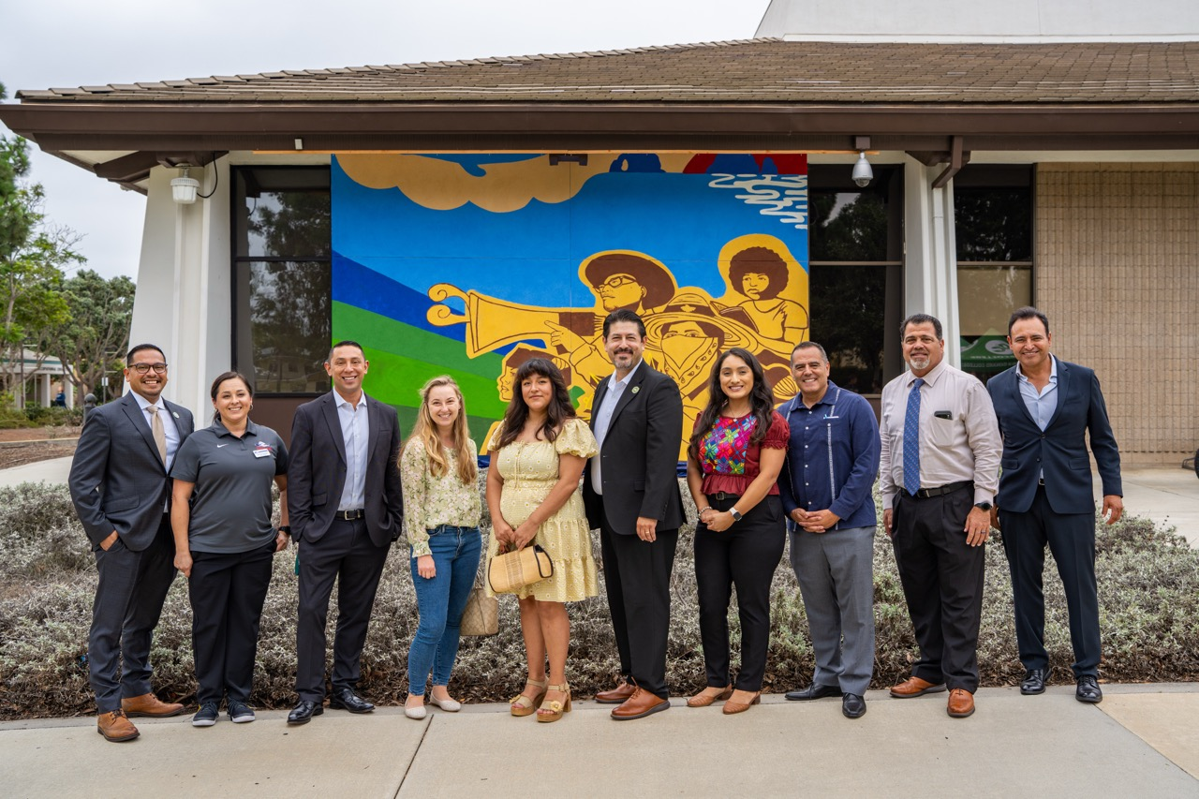

**Oxnard College Marks 50 Years of Service to Ventura County with New Programs, Academic Milestones and Campus Celebration**  
*Recent national and state recognitions highlight college’s commitment to student success and economic mobility*

**OXNARD, Calif.** (Sept. 25, 2025) — Oxnard College is celebrating its 50th anniversary this academic year, reflecting on five decades of empowering students, shaping careers and strengthening Ventura County. The milestone was marked on September 25 with the unveiling of a new campus mural by alumna Elisa Torres and her team of student artists.

Funded by the Oxnard College Foundation, the mural depicts the people, places and traditions that have defined Oxnard and the college’s role in the community over the last half-century. The college first opened its doors in 1975 after local families, community leaders and activists came together to advocate for equitable access to higher education in Oxnard.

“Oxnard College's 50th anniversary is a tribute to our roots and a commitment to the next half-century of excellence,” said Dr. Roberto Gonzalez, president of Oxnard College. “With new programs, partnerships and recognitions, Oxnard College is building the future our students and community deserve.”

Oxnard College’s 50th anniversary year has been marked by important achievements in academics and recognition for its community impact. The college recently launched its first-ever [bachelor’s degree programin dental hygiene](https://www.oxnardcollege.edu/departments/academic/dental-hygiene), welcoming its inaugural cohort of 20 students. Fully accredited by the Commission on Dental Accreditation, the program prepares students for licensure as Registered Dental Hygienists and builds on the program’s long-standing reputation for excellence in hands-on clinical training, strong board exam performance and community engagement.

Additionally, Oxnard College was recently ranked 9th in the nation among two-year Hispanic-Serving Institutions (HSIs) by the [*Washington Monthly* College Rankings](https://washingtonmonthly.com/2025/08/24/best-hispanic-serving-colleges/), which partners with Excelencia in Education to prioritize colleges advancing social mobility, equity and student opportunity. The organization provides an important alternative to traditional rankings like *U.S. News & World Report*, which focus more on prestige and selectivity. The college was also ranked among the top 10 community colleges in California for return on investment by [College Futures](https://collegefutures.org/golden-returns-2-year-roi/), with most graduates earning back their out-of-pocket expenses within just six months of graduating. This distinction underscores Oxnard College’s commitment to providing affordable, high-quality education that leads directly to economic mobility.

Oxnard College is also deepening its partnerships to expand workforce development opportunities in Ventura County. A new collaboration with the Laborers’ International Union of North America (LiUNA) will utilize campus space for hands-on training in the building and construction trades. Additionally, forward-thinking initiatives, such as a [Logistics program](https://www.oxnardcollege.edu/news/oxnard-college-launches-new-logistics-certificate-program-partnership-us-navy-and-port-hueneme) developed in partnership with the U.S. Navy and the Port of Hueneme, are also preparing students for careers in global industries rooted here at home.

Oxnard College continues to expand its existing offerings to serve the community and open doors for students of all backgrounds. The college’s English as a Second Language program has grown by 134% since 2022, serving Ventura County’s diverse communities at new locations in Oxnard, El Rio and Port Hueneme. The college is also seeing growth in its Dual Enrollment program, which has grown by 36% since 2022, giving local high school students a tuition-free head start on higher education. These efforts reflect Oxnard College’s commitment to increasing access, equity and opportunity for learners at every stage.  
  
Community leaders have taken note of the college’s continued impact. “As an alumnus of Oxnard College, I know firsthand the life-changing impact this institution has had for countless individuals,” said Oxnard Mayor Luis Mc Arthur. “For a half a century, Oxnard College has been a source of hope and support for our community, guiding individuals as they work toward their goals and build brighter, more fulfilling lives.”

To learn more about Oxnard College’s 50th anniversary events, milestones and history, [visit their anniversary page](https://www.oxnardcollege.edu/50th-anniversary).

**About Oxnard College**

*Oxnard College is one of three colleges in the Ventura County Community College District and annually serves more than 7,000 students. Founded in 1975, Oxnard College is fully accredited. It is also a designated Hispanic-Serving Institution. Oxnard College’s signature programs include marine biology; culinary arts, restaurant management and hospitality management; auto technology, dental hygiene and fire technology, among many other undergraduate study and career technical education programs. The Dream Resource Center is a valuable student and community resource. To learn more, visit* [*oxnardcollege.edu*](http://oxnardcollege.edu/) *and* [*Facebook*](https://www.facebook.com/oxnardcollege/)*,* [*Instagram*](https://www.instagram.com/oxnardcollege_official/)*,* [*LinkedIn*](https://www.linkedin.com/school/oxnard-college/) *and* [*Twitter*](https://twitter.com/OxnardCollege)*.*

Media Contact:

James Schuelke

Director of Outreach and Marketing

Oxnard College

805-678-5275

[jschuelke@vcccd.edu](mailto:jschuelke@vcccd.edu)