FOR IMMEDIATE RELEASE

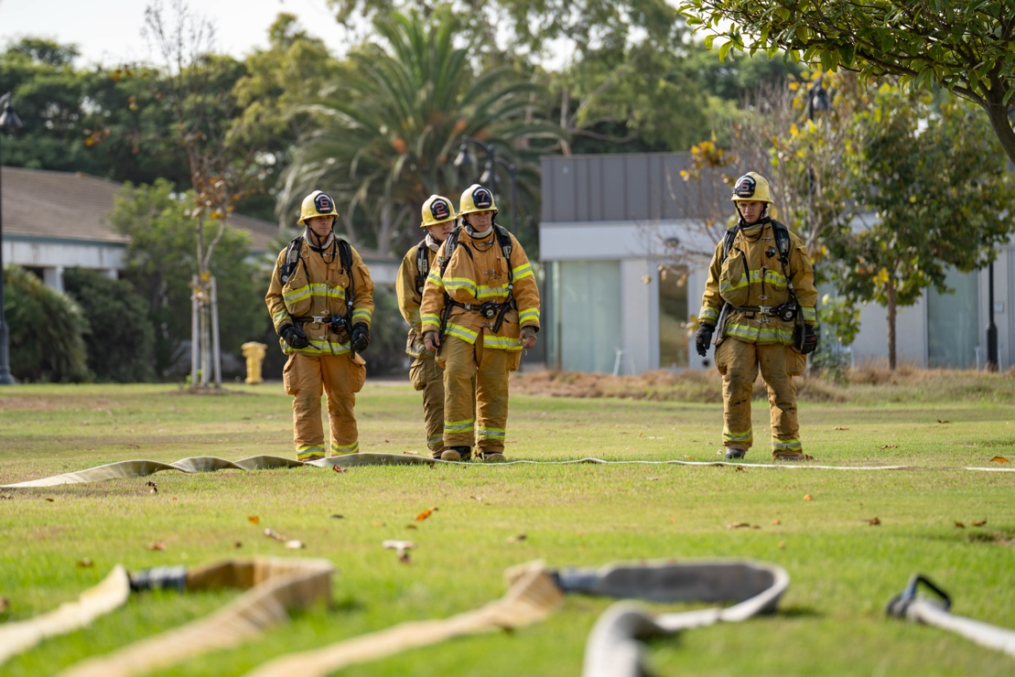

Oxnard College Receives $100,000 Grant from Metallica’s All Within My Hands’ Scholars Initiative
The Grant Will Fund Equipment for Oxnard College’s Career Education Students

Oxnard, Calif. (Aug. 21, 2023) — Oxnard College has been selected to receive a $100,000 grant from the Grammy Award-winning band Metallica and its foundation, All Within My Hands. The award will support students in the college’s Culinary Arts, Dental Hygiene and Fire Academy programs as the band continues its multimillion-dollar investment in critical workforce programs at community colleges nationwide.

The Metallica Scholars Initiative (MSI) was launched in 2019 by Metallica’s foundation, All Within My Hands (AWMH), in partnership with the American Association of Community Colleges (AACC). The workforce initiative marks its fifth year with an ambitious expansion into new curricula. MSI now directly supports 42 community colleges across 33 states, and by the end of this year, it will have helped over 6,000 students pursuing careers in the trades. To date, Metallica and AWMH have invested over six million dollars in the American workforce through career education programs like those at Oxnard College.

“We’re honored to be recognized by Metallica and are grateful for their commitment to supporting Oxnard College’s impactful career education programs,” shared Dr. Oscar Cobian, Interim President of Oxnard College. “This grant will help provide much-needed technical instruments, tools and safety gear to over 100 of our hardworking students.”

The grant will fund equipment for Oxnard College students such as fire safety boots for Fire Academy cadets, professional knife kits for Oxnard College’s Culinary Arts students and dental instrument kits for Dental Hygiene students. Oxnard College’s services for career education students will also extend counseling and subsidized services such as child care, SNAP benefits and other support to Metallica Scholars and their families.

“The Metallica Scholars Initiative is so important to us because we are seeing results,” said Lars Ulrich, drummer and co-founder of Metallica. “Five years into our efforts, with the help of community colleges across the country, we are helping people fill these essential jobs which require skills and training. We are so proud and grateful that we can facilitate this program.”

The 11 schools joining MSI this year include:

- Aiken Technical College — Aiken, South Carolina
- Central Wyoming College — Riverton, Wyoming
- Columbia State Community College — Columbia, Tennessee
- Front Range Community College — Westminster, Colorado
- Itawamba Community College — Fulton, Mississippi
- Northeast Wisconsin Technical College — Green Bay, Wisconsin
- Oxnard College — Oxnard, California
- South Central College — North Mankato, Minnesota
- South Louisiana Community College — Lafayette, Louisiana
- Texas State Technical College — Waco, Texas
- Western Dakota Technical College — Rapid City, South Dakota

These newly added colleges are joining a roster of veteran schools invited to continue in the program. Each year, the program’s returning colleges play an integral part in helping guide the success of the newest schools.

“The Metallica Scholars Initiative is a strong and cooperative assemblage of the nation’s best community colleges, creating a supportive climate for participants to communicate directly and share best practices,” shared Peter Delgrosso, AWMH’s executive director. “As a result, our Metallica Scholars leave the program well-trained and confident. Ultimately, the impact is felt locally and nationally as Metallica Scholars enter workforce and fill in-demand technical positions.”

Oxnard College will select its first round of Metallica Scholars during the fall semester, and the program will help launch a community fundraising campaign through the Oxnard College Foundation to support the college’s career and technical education programs. Donations can be made through the Foundation’s Metallica Scholars campaign at oxnardcollegefoundation.org/metallica-scholars. Questions regarding the college’s plans can be directed to James Schuelke at jschuelke@vcccd.edu.

About Oxnard College
Oxnard College is one of three colleges in the Ventura County Community College District and annually serves more than 7,000 students. Founded in 1975, Oxnard College is fully accredited. It is also a designated Hispanic-Serving Institution. Oxnard College’s signature programs include marine biology; culinary arts, restaurant management and hospitality management; auto technology and fire technology, among many other undergraduate study and career technical education programs. The Dream Resource Center is a valuable student and community resource. To learn more, visit oxnardcollege.edu and Facebook, Instagram, LinkedIn and Twitter.

About American Association Of Community Colleges (AACC)
As the voice of the nation’s community colleges, the American Association of Community Colleges leads, advocates, and advances the nation’s community colleges. Uniquely American, community colleges deliver educational and economic opportunities for more than 10 million diverse students annually. Dedicated to access and success for all students, AACC’s member colleges provide an on-ramp to degree attainment, skilled careers, and family-supporting wages. Located in Washington, DC, AACC advocates for these not-for-profit, public-serving institutions to ensure they have the resources and support to increase economic mobility for all.

About All Within My Hands (AWMH)
All Within My Hands was established in 2017 by Metallica to invest in the people and places that have supported the band. It also allows Metallica’s fans to engage in philanthropy and volunteerism. The Foundation is dedicated to creating sustainable communities through workforce education, the fight against hunger, and other critical local services. All expenses of the Foundation are covered by the band, the board, and a few special friends so that 100% of donations go to the organizations it supports. AWMH is a registered 501(c)3 non-profit organization.

Media Contact:
James Schuelke
Director of Outreach and Marketing
Oxnard College
805-678-5275
jschuelke@vcccd.edu

