 | 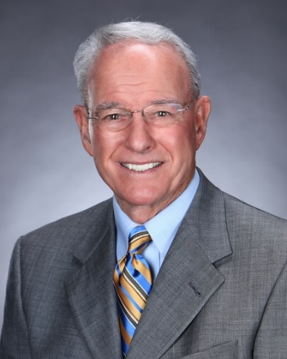
Debra Sharp | Jerry White
FOR IMMEDIATE RELEASE

Oxnard College’s Athletic Department Hosts Inaugural Hall of Fame Banquet
College will honor Ventura County Sports Hall of Fame
recipients Debra Sharp and Jerry White
Oxnard, Calif. (May 11, 2022)—The Oxnard College athletic department will host its inaugural Hall of Fame Banquet on May 21, honoring two outstanding Oxnard College athletic alumni and celebrating the new Oxnard College Athletic Alumni Association. Former athletes, alumni and the general community are invited to attend a reception and dinner commemorating inductees cross-country runner Debra Sharp and baseball coach Jerry White. The 5 p.m. event will be held at the Oxnard College Performing Arts Center.

“Jerry and Debra built a strong foundation for Oxnard College athletics and paved the way for countless student-athletes to follow,” said Jonas Crawford, athletic director at Oxnard College. “Celebrating their mark on our program is long overdue, and we’re looking forward to an evening dedicated to these two stalwarts of Oxnard College athletics.”
“We’re thrilled to celebrate the lasting legacy of our athletic department and its notable alumni,” added Dr. Oscar Cobian, acting president of Oxnard College. “Jerry and Debra represent a long line of success both on the field and in the classroom—we look forward to recognizing their achievements.”

Sharp is a two-time recipient of the Ventura County Sports Hall of Fame’s College Women’s Athlete of the Year award (1987 and 1988), a former Western State Conference (WSC) Cross Country Champion (1988) and is the current Oxnard College 5K record holder. She ran cross country for Oxnard College for two years (1987 and 1988), earning third place at both the SoCal Finals and the California Community College Athletic Association’s State Championships. In addition, she received Oxnard College’s Scholar-Athlete of the Year in 1987.

After transferring to Cal State Northridge, Sharp helped Oxnard College earn a third-place finish in cross country at the 1989 WSC Conference Finals as an assistant coach. She later ran 2:42.28 at the 1987 San Francisco Marathon, which qualified her for the 1988 U.S. Olympic Trials for the Women’s Marathon in Pittsburgh, Pa.
White led Oxnard College to five WSC Baseball Championships and was the WSC Coach of the Year three times while amassing 235 wins as head baseball coach. The Ventura County Sports Hall of Fame Award recipient also served as Oxnard College’s Athletic Director before becoming Commissioner of the Western State Conference. The longtime NCAA Division I Men’s Basketball referee currently serves on the California Community College Athletic Association’s Board of Directors. He has been an official scorer for the Los Angeles Dodgers since 2014.
Oxnard College offers award-winning athletic teams for students, including men’s baseball, basketball and soccer, as well as women’s softball, basketball, soccer and cross country. Alumni of the department are encouraged to join the new Oxnard College Athletic Alumni Association.

Oxnard College’s inaugural Hall of Fame Banquet will take place in the Oxnard College Performing Arts Center Conference Room, 4000 South Rose Ave., Oxnard. Tickets for the Banquet are $50 per person and can be purchased through the Oxnard College Athletic Alumni Association website at OCAthleticAlumni.com.

About Oxnard College
Oxnard College is one of three colleges in the Ventura County Community College District and annually serves more than 7,000 students. Founded in 1975, Oxnard College is fully accredited. It is also a designated Hispanic-Serving Institution. Oxnard College’s signature programs include marine biology; culinary arts, restaurant management and hospitality management; auto technology and fire technology, among many other undergraduate study and career technical education programs. The Dream Resource Center is a valuable student and community resource. To learn more, visit oxnardcollege.edu and Facebook, Instagram, LinkedIn and Twitter.

Media Contact:
James Schuelke
Director of Outreach and Marketing
Oxnard College
805-678-5275
jschuelke@vcccd.edu

