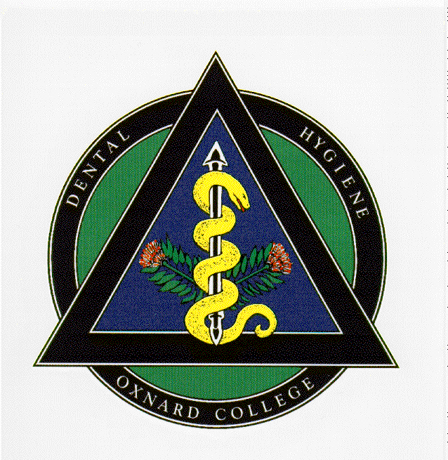
Dear Dental Hygiene Applicant,

We are delighted that you have elected to apply to Oxnard College Dental Hygiene Program. We have an outstanding program and would love to add you to our group of esteemed alumni!

Below is a check off list of all the necessary documentation that must be submitted in a complete application packet. Incomplete or late applications will not be considered. .

_____ Dental Hygiene Application (completed)
_____ Proof of High School Graduation
_____ Official College Transcripts (hard copy in sealed envelope only--no electronic transcripts accepted)
_____ CPR Certification (Copy of current card) American Heart Association or American Red Cross course in Basic Life Support (BLS/CPR) with a live in-person skills component.
_____ Proof of completion of DH R001, or proof of enrollment in DH R001

Failure to submit ALL of the above items together will be considered an incomplete application packet and mean that you cannot be included in the lottery selection process. All complete application packets must be delivered to the Dental Hygiene Department by the deadline, no exceptions.

If you have any questions, do not hesitate to call 805-678-5823.

Please deliver your application packet to:

Oxnard College
Dental Hygiene Department
4000 South Rose Avenue
Oxnard, CA 93033-6699

Attn: Susan McDonald

Thank You,

Susan McDonald, RDH, M.Ed.
Dental Hygiene Program Director

application FOR ADMISSION: OXNARD COLLEGE DENTAL HYGIENE Program

Last Name First Name Middle Name Maiden/AKA

Mailing Address Mailing City, State, Zip
______ ________________ _______________________
Date of Birth Age Gender Phone Email

High School Education Status (Circle One): HS Diploma; Foreign Diploma/Certificate of Graduation; G.E.D.; Other Name of HS & Year graduated: _______________________ Specify if “Other” was selected: ________________

List ALL colleges and universities attended even if courses are not Dental Hygiene applicable (attach additional pages if more than 3 colleges).
Attach official transcripts for each college listed (VCCCD only one transcript required): Envelope must remain sealed
** NO Electronic Transcripts *** Transcripts and a copy of your CPR Card must be submitted with the application prior to deadline
Name of college or university attended | COLLEGE LOCATION  City, State | Term(S) and year(S) attended | Degree earned | offical use only
Minimum Cumulative GPA is 3.0 (including ALL colleges ever attended). Minimum Science GPA is 3.0 (including ALL science prerequisites). Oxnard College GPA calculations may vary from other institutions.
PREREquiSITE courseS  (OxNARD cOLLEGE) | course title/number  (eQUIVALENT pREREQ. COURSE) | UNITS | college  (where taken) |  | term taken (SEM/yR) |  | grade | offical use only
MICR R100
Prin. Of Microbiology
MICR R100L
Prin. Of Microbiology Lab.
MATH R005 or R015
Beg & Int Algebra
ANAT R101
Gen. Human Anatomy
PHSO R101
Human Physiology
CHEM R110
Elementary Chemistry
CHEM R112
Elem. Organic & Bio. Chem.
ENGL R101
College Composition
PSY R101
General Psychology
SOC R101
Intro to Sociology
COMM R101
Intro to Oral Communication
ANTH R102
Cultural Anthropology
DH R001  Intro to Dental Hygiene | Include proof of passing or enrollment in DH R001 at Oxnard College

OFFICAL USE ONLY
Spring 2021
Receiver: _______
Date received: ______
Applicant #: ______
I certify, under the penalty of disqualification, that the statements in this application are true to the best of my knowledge and ability. I understand that submission of inaccurate, falsified, or incomplete information may disqualify me for entrance into the Oxnard College Dental Hygiene Program. I acknowledge that it is my responsibility to ensure the Dental Hygiene Department receives all documentation by the deadline.

_____________________
Applicant Signature Date

This survey information is confidential and is used only for statistical reporting purposes only.
The information is not collected in relation to the selection process of applicants.

Dental Experience (check all that apply):
_____None
_____Dental Office Experience
_____Dental Assistant → years & type of experience ___________________________________________________
_____Registered Dental Assistant (R.D.A) → years & type of experience ___________________________________
If RDA, did you graduate from an accredited Dental Assisting school? ________________________________
_____Dental Lab Technician → years & type of experience ______________________________________________
If Dental Tech, did you graduate from an accredited Dental Tech school? ____________________________

Ethnicity (check one):
_____ American Indian or Alaskan Native
_____ Asian or Pacific Islander
_____ Black African American, not of Latino/Hispanic origin
_____ White, not of Latino/Hispanic origin
_____ Latino/Hispanic
_____ Other

Citizenship Status (check one):
_____ Canadian Citizen
_____ U.S. Citizen
Not U.S. Citizen:
_____ Permanent Resident Visa
_____ Temporary Resident/Amnesty
_____ Refugee/Asylee
_____ Student Visa (F-1 or M-1)
_____ Other Visa or Visa Type
_____ Unknown

Student Academic Level (check current one):
_____ I have attended only one year of college and have not earned a Degree
_____ I have attended two years of college and have not earned a Degree
_____ I have attended three years of college and have not earned a Degree
_____ I have attended four years of college and have not earned a Degree
_____ I have already earned or will have earned an Associate’s Degree by the time of program entry
_____ I have already earned or will have earned a Bachelor’s Degree or higher by the time of program entry
_____ Other, please specify_____________________________________________________________

Student Educational Goal (select your highest priority)
_____ Earn a Dental Hygiene certificate/A.S. degree without transfer
_____ Earn a Dental Hygiene certificate/A.S. degree with transfer to obtain a Bachelor’s degree or higher

Financial:
_____ I will request financial aid while I attend the program
_____ I will not request financial aid while I attend the program

Employment/Family Care Responsibility (check all that apply):
_____ I will work part-time while I attend the program
_____ I will work full-time while I attend the program
_____ I will have family care responsibilities (caring for children, elderly parents, disabled spouse, etc.) while I
attend the program

