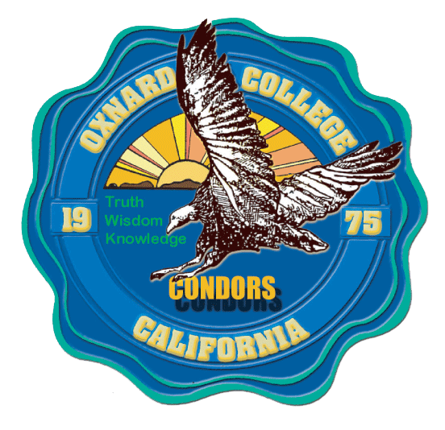
PROFESSIONAL DEVELOPMENT COMMITTEE

Meeting MINUTES

Present: Juan Pitones, Leah Alarcon, Berenice Rodriguez, Amparo Medina, Jaqueline Ta, Carolyn Inouye, Kevin Corse, Armine Derdierian, Tim Fontenette, Adam Hart, Anitra Lawson. Yong Ma, Claudia Parsons, Kari Tudman
Guests: Oscar Cobian

Meeting Date: 11.18.19 |  | Minutes Approved: 10.21.19 |  | Recorded By: M.Castelo
AN = Action Needed | AT = Action Taken |  | D = Discussion |  | I = Information Only

DISCUSSION/DECISIONS

 | Called to Order | I,AT | The meeting was called to order at 2:07 p.m.
 | Public Comment | I | No public comment.
 | Adoption of the Agenda | I,AT | The Committee members reviewed the agenda. Yong Ma motioned to adopt the agenda; Kevin Corse seconded and the agenda was unanimously adopted.
 | Approval of Meeting Minutes | I,AT | The Committee members reviewed the minutes of the 10.21.19 meeting.  Claudia Parsons motioned to approve the minutes; Amparo Medina seconded and the minutes were unanimously approved.
 | Review of Goals Activities & Membership | I, AT | A handout that outlines the activities/charge of the PDC was distributed and reviewed. Some revisions were suggested. Leah Alarcon will revise the handout and submit to PDC members for review.
 | Spring Flex Activities | I | Juan and Leah will be sending out an all users email to invite participants to submit ideas and/or hold a workshop for flex week in the Spring 2020.
 | Future Agenda Items |  | - Rolling deadline for Classified Staff (Faculty by Semester)  - We Speak  - Application Guidelines (Documents Required)  - Criteria for overnight stay (Drive early AM or Stay Overnight)  - International Travel
 | Adjournment | I | The meeting adjourned at 3:45 p.m.
 | Future PDC Meetings | I | 2019: Dec. 16  2020: Jan. 29, Feb. 18, Mar. 16, Apr. 20

