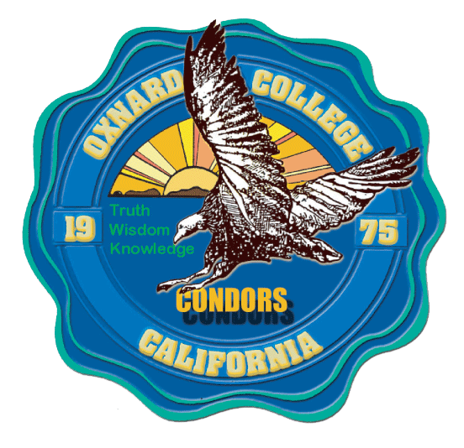
PROFESSIONAL DEVELOPMENT cOMMITTEE

Meeting MINUTES

Present: Juan Pitones, Leah Alarcon, Bernice Rodriguez, Amparo Medina, Yong Ma, Tim Fontenette, Charles Ramirez, Jacquelyne Ta, Kari Tudman, Anitra Lawson, Claudia Moreno Parsons, Randall Searcy, Diane Eberhardy, Laura Gentry, Robert Chaparro, Oscar Cobian, Samantha Kaastad Gardner.
Absent:

Meeting Date: 9-16-19 |  | Minutes Approved: 4-15-19 |  | Recorded By: Lori Jay
AN = Action Needed | AT = Action Taken |  | D = Discussion |  | I = Information Only

DISCUSSION/DECISIONS

 | Called to Order | I,AT | The meeting was called to order at 2:02 p.m.
 | Public Comment | I | Randall Searcy spoke about the tutoring in the LLRC. Bridging together the various tutoring programs.
 | Adoption of the Agenda | I,AT | The Committee members reviewed the agenda. A. Medina motioned to adopt the agenda; C. Ramirez seconded and the agenda was unanimously adopted.
 | Approval of Meeting Minutes | I,AT | The Committee members reviewed the minutes of the April 15, 2019 meeting.  Y. Ma motioned to approve the minutes; A. Medina seconded and the minutes were approved.
 | Review of Membership & Charge |  | D. Eberhardy introduced herself and thanked J. Pitones for being the Co-chair of this committee. She discussed the Participatory Government manual as a guide for all of the PG meetings. The college is in the process of updating the manual. The Committee reviewed the handout, “Professional Development Committee” from the manual.  D. Eberhardy asked if this committee will be using the new rubric. J. Pitones stated that they would. He will bring this up in the next meeting.  Introductions were made around the room with a clarification of the voting members.  Y. Ma asked if there is a member of all departments at this meeting. D. Eberhardy will put out an email to all to have more members at this meeting.  A Medina recommended that PG meetings have tri-chairs. She reviewed the committees of other colleges in the state. This would be for all of the PG meetings on our campus. Her recommendation is to have a smaller group for PDC meetings but to have tri-chairs.  D. Eberhardy stated that it is important to know who is on the Committees. There was discussion of having the members get familiar with the function of this Committee before voting on any items. A. Medina encouraged conversation among members. This Committee could take on a bigger roll on this campus.  There was discussion of having Professional Development opportunities big and small for Faculty and Staff perhaps once per month. There was concern of budget funded events. D. Eberhardy suggested having this conversation among their departments. J. Pitones suggested finding our purpose first and then go from there.
 | Review Travel Requests & Deadlines |  | J. Pitones discussed the applications for travel. The application will be emailed out to Faculty and Staff soon. This will also be posted on SharePoint for PDC. October 21, 2019 is the deadline for applications. A. Medina suggested having the Classified due date be a rolling date. She wants to encourage the Classified to attend Professional Development opportunities.  There was discussion of the rubrics, what is primary, student conferences. Oscar asked if the rubric could be sent out this week. Kari suggested working on the rubric among this committee and then update the form for Spring 2020. The form needs to go through the Academic Senate. The rubric will be discussed in the November 18 meeting.  There was discussion of due dates being approximately a week before the next PDC meeting. A. Medina discussed having the Classified due dates be the first Monday of each month during the academic year. J. Pitones stated that we would need to prepare a form and rubric for Classified staff.
 | PDC Application Form |  | The Committee will be discussing the form in Jan/Feb.
 | Upcoming Professional Development Opportunities |  | A. Medina discussed the following opportunities:  - Dr. Harris – Student Success – 2:00 – October 8, 2019 - open to all  - Dr. Rios – November 5, 2019 - Open to all
 | Faculty & Staff Panel in September |  | J. Pitones discussed “We Speak”. There was discussion of it and OC Live events and transparency. A. Medina, J. Pitones and B. Rodriguez will meet as a Sub-Committee to discuss “We Speak”.
 | Future Agenda Items |  | - Rolling deadline for Classified Staff  - Deadlines  - Review of the membership  - We Speak  - Tri-chair  - Goals & Activities
 | Adjournment | I | The meeting adjourned at 3:37 p.m.
 | Future PDC Meeting | I | - January 29, 2020 at 2:00  - February 18, 2020 at 2:00

