OXNARD COLLEGE
Early Childhood Education/Child Development
Providing Early Education
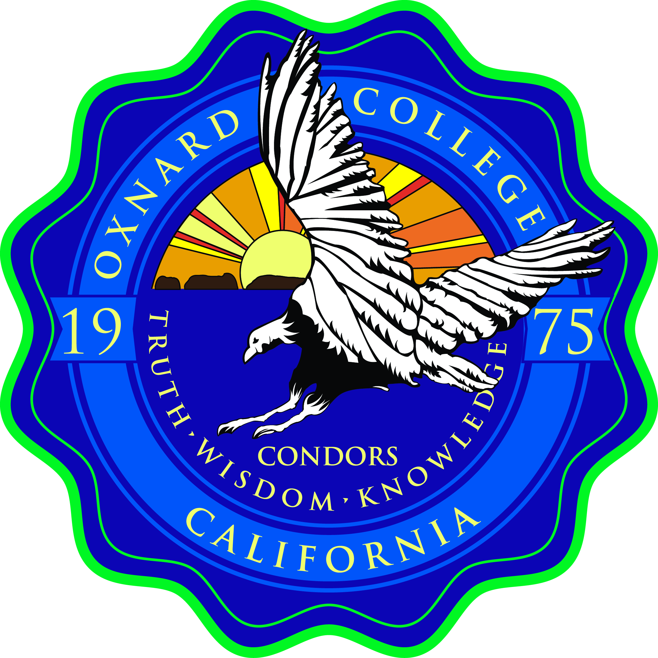
Advisory Board Members
Handbook

Thank you for agreeing to serve as a member of the Oxnard College Program’s Advisory Board. Industry, education, and community partners like you make all the difference in our ability to provide a well-educated and competent workforce. Your membership helps us help our students of all ages and backgrounds achieve success.
As an Advisory Board member, you help us ensure that our curriculum reflects industry standards, our classrooms, instructional equipment and materials are of high quality and our faculty and students share the best in applied learning, hands-on skill development and workplace practices.
Your time and energy spent on the Board matters – to families, students, to the college, to employers and to the community we serve.
Thank you,
Patricia Mendez, MA, Department Chair, Professor
Oxnard College
Early Childhood Education/Child Development
Department

What is an Advisory Board?

An advisory board is a group of individuals selected by a department to advise the program regarding education needs and activities. Members are partners in progress and help us achieve our strategic goals. Collectively, a board studies issues, advises, advocates, communicates and makes recommendations regarding:

- The expansion, reduction or deletion of programs
- Program development plans and actions
- Program marketing
- Current and forecast employment needs
- Program needs

Advisory board members are chosen because of their interest in career and technical education, specialized knowledge and experience, and who represent business, education and social services.
Our advisory board maintains membership that reflects the following characteristics:
- Capability – have recent and successful experience in early education

- Availability – are willing to make a personal commitment to be available and actively involved in meetings and activities

- Character – are enthusiastic, responsible, civic-minded and able to work cooperatively with others

- Interest – care about the future of career, technical, and community education programs

What are the Basic Functions of an Advisory Board?
An advisory board assists with many activities that improve academic programs. Each board develops its own program of work based on the needs of the program served. In developing its goals and activities for the year, a board may address some or many of the elements listed below:

Curriculum

- Recommending technical resource personnel
- Assisting in “best practice” recommendations

Program Evaluation

- Reviewing goals/objectives of the Child Development Center program
- Identifying “Ideas for Action”

Recruitment and Student Support

- Assisting students in securing internships and/or eventual employment

Public Relations

- Promoting the Child Development Program within the community
- Participating in award ceremonies and other program activities
- Recognizing outstanding students, educators and administrators

Leadership activities

- Gathering contributions of equipment/supplies for the program & events
- Sponsoring recognized program events
- Gathering new legislation information and gathering legislative support

Development

- Assisting with the identification and procurement of funding sources for program development and enhancement.
How Does the Board Operate?

Frequency – Advisory boards meet a minimum of at least once a year. Since the frequency of the meetings is determined largely by the scope of the board’s program of work, some boards may choose to meet more frequently.
Records – A designee should be appointed to take minutes of the meetings. Minutes should be maintained in the Child Development Center office and should be distributed to committee members or other stakeholders within 30 days of a meeting, but no later than 30 days prior to the next meeting.
Agenda – The agenda should include minutes of the most recent board meetings, standing or sub-committee reports as appropriate, and unfinished and new business.
Size – Generally, boards should include eight to fifteen members. Five is the minimum. The committee should not be too large. Program faculty should not be more than 20% of the total membership.
Quorum – a quorum shall be a simple majority of members.
Attendance – Members not attending or participating via distance of the scheduled meetings should be replaced to maintain a viable committee.
What is expected of an Advisory Board member?

A successful advisory board is one that accomplishes its annual goals and objectives. Therefore, it is essential individuals accepting board appointments are willing to attend meetings and actively participate in board activities.

Responsibilities usually include:

- Participating in meetings on a regular basis, (At least 1 per year.)

- Serving in a leadership capacity (such as chair, vice chair, minute taker, etc.)

- Suggesting agenda items and developing those items prior to board meetings

- Helping to determine the goals, objectives, agendas, and meeting dates

- Becoming familiar with the Oxnard College and the VCCCD organization

- Abstaining from participation when a conflict of interest is possible, whether political of personal

- Members include: business and industry partners, faculty, and students.

Ethics and Conflict of Interest

No member of the Advisory Board shall have financial or other interests that would conflict with the discharge of their duties as members of the committee. This does not preclude instructors from serving on the Advisory Committee. If any item comes before the committee that would directly benefit the instructors then those people on the committee who are Oxnard College instructors would be expected to abstain from voting on said items.

